Sean Tveter

12/04/2022

IT FDN 100 B

Assignment 8

# Knowledge Document 08

# Introduction

For this week’s module, I went into it with some doubts. This weeks Zoom class was also pretty confusing to me and I left feeling a bit confused. I went through my usual process for preparing for this weeks assignment. I started by reading and taking notes in the chapter, the book made a lot of sense and I practiced some of the functions in Spyder just to get a hang of them. After this, I watched the videos online and read through the module document. This document I also really struggled with. I spent a lot of time trying to get the classes to work correctly, but couldn’t quite get everything together. To turn in a completed assignment and not a broken code that wasn’t working all the way, I finished it the best that I could using what we have already learned.

# Assignment

To begin this assignment, I started on the main body of the code, because I figured that this was where I could accomplish the most. Because we have been working with the CD Inventory for so many weeks, I’ve gotten the hang of the basic outline of them. I used previous assignments to help found this section to be relatively easy. One of the bigger changes I made compared to previous weeks was adding some information to the text document to be displayed once the user logs into the program.

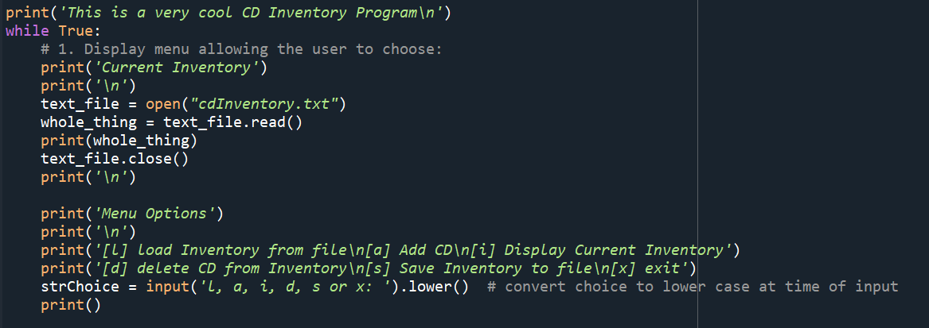

I think that by allowing the user to see what data looks like when it is successfully entered, it would help them to better understand the program. Secondly, to accomplish this I had to add a function that would read the ‘txt’ file and print the data it found in there. This took some troubleshooting, but eventually using an altered version of an example of what I found in the book helped me the most. After completing these sections, I struggled to take my main body code and incorporate it into object-oriented programming. Reading through the text document was confusing, and being low on time this week I opted for something that I knew how to complete.

Finally, I apologize for not being able to include a picture or my code working from the command prompt for a while. I keep receiving an error message, I’ve done a bunch of digging on the web but can’t seem to understand what is happening.

# Summary

Similar to last weeks assignment, I feel like I have learned so much but have struggled to implement it on the first time through. I am excited to attend class this week to see what errors I made and what improvements I can make so I can get this right the next time. I am very excited to continue learning and broaden my knowledge of coding.